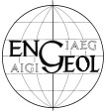 | 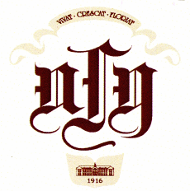 | 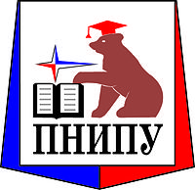 |  | 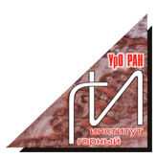 | 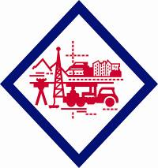
 |  | 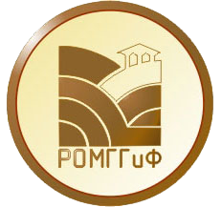 | 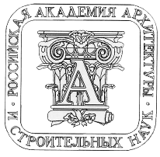 | 
INTERNATIONAL ASSOCIATION FOR ENGINEERING GEOLOGY AND THE ENVIRONMENT (IAEG)
PERM STATE UNIVERSITY (PSU)
PERM NATIONAL RESEARCH POLYTECHNIC UNIVERSITY (PNRPU)
SERGEEV INSTITUTE OF ENVIRONMENTAL GEOSCIENCE RAS (IEG RAS)
MINING INSTITUTE OF THE URAL BRANCH OF THE RUSSIAN ACADEMY OF SCIENCES
JSC «VERKHNEKAMTISIZ»
JSC «KARST-CONTROL AND BANK PROTECTION»
RUSSIAN SOCIETY FOR SOIL MECHANICS, GEOTECHNICS AND FOUNDATION (RSSMGFE)
RUSSIAN ACADEMY OF ARCHITECTURE AND CONSTRUCTION SCIENCES (RAASN)
CHARITABLE TRUSTEESHIP FUND OF PERM STATE UNIVERSITY «UNIFOND»

The First Circular

INTERNATIONAL SYMPOSIUM

ENVIRONMENTAL SAFETY AND CONSTRUCTION IN KARST AREAS

Dear Colleagues!

In May 2012, the All-Russia conference with international participation «Geotechnical problems of building design on karst hazard territories» was held successfully in Ufa. At this conference it was decided about the expediency of holding such conferences every three years.

The International Symposium «Environmental safety and construction in karst areas» is planned to be held in Perm at the Perm State University on May 26-29, 2015.

Perm is the most suitable place for hosting the Symposium due to the structural-geological, hydrogeological, geomorphological and technogenic uniqueness of this CisUral region.
Almost all karst types and forms are manifested there. Over an area of 30 000 km², limestones, dolomites, gypsums, anhydrites and rock salts crop out or occur close to the surface. This variety of karst forms gave birth to a number of complex problems in economic development of the karstified areas; however, at the same time, it has triggered the priority development of practical and theoretical concepts of karstology in this region.
The development of karstology in Russia in general and in Perm school, in particular, has been inseparable linked with the names of such scientists as G.A. Maximovich, K.A. Gorbunova, I.A. Pecherkin, V.N. Dublyansky, V.S. Lukin and many others, who made a major contribution to the development of Russian and worldwide karstology.
The Symposium will provide a good opportunity for strengthening personal contacts between karst researchers for promoting international cooperation. The Symposium will elucidate the significant role of theoretical and practical karstology in the scientific community of the XXI century.

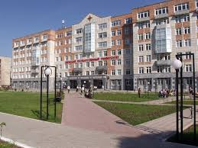 | 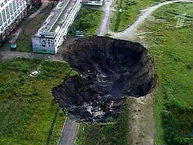
Perm State University | Sinkhole in Berezniki city

ORGANIZING COMMITTEE:
Kataev Valery Nikolaevich, chairman – Perm State University, Perm, Russia.
Osipov Viktor Ivanovich, co-chairman – Institute of Environmental Geosciences RAS, Moscow, Russia.
Baryakh Alexander Abramovich – Mining Institute Of The Ural Branch Of The Russian Academy Of Sciences, Perm, Russia.
Esyunin Oleg Leonidovich – JSC «VERKHNEKAMTISIZ», Perm, Russia.
Gotman Alfred Leonidovich – BashNIIStroy, Russian Society For Soil Mechanics,
Geotechnics And Foundation Engineering, Ufa, Russia.
Korotaev Vladimir Nikolaevich – Perm National Research Polytechnic University, Perm, Russia.
Leontiev Grigory Vladimirovich – JSC « Karst-control and bank protection», Dzerzhinsk, Russia.
Sherstnev Valery Aleksandrovich – Perm State University, Perm, Russia.

SCIENTIFIC COMMITTEE:
Aderhold Gabriele – Hessisches Landesamt für Umwelt und Geologie, Wiesbaden, Germany.
Anikeev Alexander Viktorovich – Institute of Environmental Geosciences RAS, Moscow, Russia.
Gotman Natalia Zalmanovna – BashNIIStroy, Russian Society For Soil Mechanics,
Geotechnics And Foundation Engineering, Ufa, Russia.
Khomenko Viktor Petrovich – Moscow State University of Civil Engineering, Moscow, Russia.
Kostarev Vitaly Petrovich – JSC «VERKHNEKAMTISIZ», Perm, Russia.
LaMoreaux James – President of P.E. LaMoreaux and Associates, Editor-in-Chief of International Journal of Environmental Geology, Tuscaloosa, Alabama, USA.
Lempe Bernhard – Technische Universität München Lehrstuhl für Ingenieurgeologie, Munich, Germany.
LU Yaoru – Chinese Academy of Engineering, Chinese Academy of Geological Sciences, Tongji University, Shanghai, China.
Maksimovich Nikolai Georgievich – Natural Sciences Institute of Perm State University, Perm, Russia.
Milanović Petar – President of Serbian IAH Chapter, Belgrade, Serbia.
Ponomarev Andrey Budimirovich – Perm National Research Polytechnic University, Perm, Russia.
Sanfirov Igor Aleksandrovich – Mining Institute Of The Ural Branch Of The Russian Academy Of Sciences, Perm, Russia.
Sorochan Evgeny Andreevich – NIIOSP, Moscow, Russia.
Tolmachev Vladimir Viktorovich – JSC «Karst-control and bank protection», Dzerzhinsk, Russia.
Weinstein Mikhail Semenovich – JSC «Mosproject», Moscow, Russia.

Preliminary Symposium Schedule:
May 26 – arrival and accomodation in the hotel, registration of participants, acquaintance with Perm State University and Perm National Research Polytechnic University.
May 27, 28 – opening of the Symposium, plenary and section sessions.
May 29 – excursions to the karst objects of Permskiy Krai, closure of the Conference, departure of participants.

Symposium invites to discuss the following issues:
- Engineering research methods in karst regions and organization of karst monitoring;
- Evaluation of karst hazard and risk;
- Pollution of the geological environment in karst regions and protective measures;
- Device of the foundations and underground construction in karst areas;
- Examples of designing buildings in karst regions;
- Karst-control measures upon projecting of highly dangerous and technologically complex objects;
- Analysis of emergencies and insurance specifics of engineering structures with the account of karst risks;
- Regulatory and methodical documents on survey, design and construction in karst regions;
- Construction and exploitation of buildings and structures in karst areas.

Official working languages of the Symposium are Russian and English. The service of simultaneous translation will be provided.

We invite you to participate in the Symposium and we will be grateful for circulating this information among your colleagues and interested organizations. Please, confirm your intent of participation by filling the following form:

EXAMPLE OF REQUEST FORM

Full Name | Ivanov Ivan Ivanovich
Affiliation | Perm State University
Address of Work / Study | 614990, Perm, Bukireva st., 15
Position, Academic Degree, Academic Rank | Associate Professor, PhD
Contact Phone | +73421234567
E-mail | ivanov@email.ru
Title of Report | Design and Construction in the Karst Areas
Form of Participation (personal attendance, publication only) | Full-time
Form of presentation of report (oral, poster) | Oral
Participation In Excursions | Yes

PAPER PRESENTATION REQUIREMENTS

Proceedings of the Symposium must be submitted to editors before April 6, 2015 by e-mail in electronic form and typed in MS Word. Paper size is A4, portrait orientation. Fields: left/right – 1.15 cm, lower – 1.3 cm, upper – 1.2 cm. Text formatting in two columns, font Times New Roman, 12 pt, line spacing – 13 pt. Width of column – 9 cm, spacing between the columns is 0.7 cm. First line indent – 0.5 cm, for the first paragraph in section – 0 cm. The text of the article should not exceed 5 pages. The number of authors per paper should be no more than 3.
Title of report, authors, affiliation, city, country and abstract printed in the beginning of the paper and composed without division on columns. The title of paper is typed in the first line, font Times New Roman, 18 pt, tag after – 19 pt, line spacing – 20 pt. Initials of authors are typed in the second line, font Times New Roman, 14 pt, line spacing – 16 pt. Affiliation, city and country are typed in the third line, font Times New Roman, 12 pt, italic, line spacing – 16 pt.
Captions of tables are typed above, without a paragraph, justified alignment. Figures are performed in grayscale, captions above, without paragraph, justified alignment. The font of captions of tables and figures are Times New Roman, 10 pt, tag after for tables – 3 pt, tag before for figures – 3 pt, line spacing – 11 pt.
Equations are typed in Microsoft Equation module, on the right hand from formula in parentheses is indicated its number.
It is recommended to structure text of the report on sections.
References must be presented in alphabetical order, contain no more than 16 items, font Times New Roman, 10 pt, hanging indent – 0.5 cm, line spacing – 11 pt. The name of journal or collected papers is typed italics.
The members of the Organizing Committee reserves the right not to include reports that do not meet the symposium topics.

Papers exceeding 5 pages and not complying with the template will not be accepted.
The template for paper compilation in MS Word format placed on the symposium website.

REGISTRATION FEE

Form of participation | Registration fee  (including VAT)
Full-Time (Ordinary person) | 200 €
Full-Time (IAEG members) | 180 €
Full-Time (Students, Graduate Students) | 100 €
Distance | 100 €
Accompanying person | 50 €

The registration fee includes synchronous translation, preparation and publishing of Symposium's materials, souvenirs with Symposium symbology, transfer between organizations-partners, coffee breaks, organizing of cultural program.
The registration fee doesn’t cover hotel accommodation, excursions and meal.

IMPORTANT DATES

Filled request form, paper and copy of receipt payment of organization fee must be send in address of organization committee till 15 May, 2015.
All materials should be sent via Symposium website: www.karst.psu.ru.

LIST OF HOTELS

Hotel | Website | Category | Room prices (1 person accommodation), €
Hotel Complex «Zhemchuzhina» | http://hotel-gem.ru/rus/hotel | 4 stars | 90-320
Hotel «New Star» | http://www.newstar-hotel.ru/ | 4 stars | 50-275
Hotel «City Star» | http://citystar-hotel.ru/ru/rooms/ | 4 stars | 80-190
Hotel Complex «URAL» | http://www.hotel-ural.com/rooms/ | 3 stars | 65-255
Premier-hotel «AMAKS» | http://perm.amaks-hotels.ru/ | 3 stars | 65-200
Hotel complex «Vizit» | http://www.hotelvizit.perm.ru/ | 3 stars | 60-110

VISA SUPPORT

If you need Visa support to travel in Russian Federation fill the form below and send to the organizing committee email. With filled form also send a scanned copy of passport and education document.

Last Name
Name
Patronymic
Date and place of birth
Passport series and number
Date of issue and date of expiry of passport
Full home address
Place of work/study: name of organization and full address
Position
Trip dates to Russian Federation
Place of receive Russian Visa: Country, City (where consulate of Russian Federation available)
Cities to visit in Russian Federation
Purpose of travel

CONTACTS

Secretariat members:
Shilova Anna Vladimirovna – executive secretary;
Zolotarev Denis Rafailovich, scientific associate;
Shcherbakov Sergey Vladimirovich, scientific associate.

Zip Code, address, phone, e-mail of secretariat:
Perm State University, 15, Bukirev St., Perm, 614990, RUSSIA; phone: +7(342)2396668; e-mail: karst2015@gmail.com; web: http://karst.psu.ru/.

